DESIGN AND IMPLEMENTATION OF CAR INSURANCE MANAGEMENT SYSTEM

(A CASE STUDY OF CAR INSURANCE COMPANY LIMITED KANO)

**ABSTRACT**

*This study examines the design and implementation of an online car insurance management system for Car Insurance Company Limited, Kano, with a focus on addressing the challenges faced by users and managers in the car insurance process. The rapid growth of technology and the need for secure, efficient, and user-friendly platforms have made the adoption of online systems essential in the insurance industry. The research employs a structured methodology, including system analysis through surveys and interviews with stakeholders, and system development using technologies such as PHP, MySQL, HTML/CSS, and JavaScript. Key findings highlight the importance of centralizing communication (70%) and enhancing platform security to reduce fraud risks (60%). The study identifies the potential for scalability and improved user experience but also notes the need for comprehensive user training and adoption strategies. This research contributes to the understanding of how digital transformation can streamline insurance operations, providing valuable insights for insurance companies and policymakers aiming to modernize service delivery and enhance customer satisfaction.*

## Table of Content

**CHAPTER ONE: INTRODUCTION**  
**1.0 Introduction**

**1.1 Background of the Study**

**1.2 Statement of the Problem**  
1.2.1 Lack of a Centralized Platform for Communication  
1.2.2 Increased Risk of Fraudulent Activities  
1.2.3 Limited Accessibility for Users  
1.2.4 Inefficiencies in Handling Customer Demands

**1.3 Aim and Objectives**  
1.3.1 Aim of the Study  
1.3.2 Objectives of the Study

**1.4 Scope and Limitations**  
1.4.1 Scope of the Study  
1.4.2 Limitations of the Study

**1.5 Significance of the Study**  
**1.6 Justification of the Study**

**CHAPTER TWO: LITERATURE REVIEW  
2.0 Introduction**

**2.1 Insurance Management Systems**  
2.1.1 Evolution of Insurance Management Systems in Developing Economies  
2.1.2 Traditional vs. Digital Insurance Processes: Challenges and Opportunities  
2.1.3 Benefits of Automated Insurance Systems for SMEs

**2.2 Fraud Prevention in Car Insurance**  
2.2.1 Common Types of Fraud in Car Insurance Policies  
2.2.2 Importance of Secure and Verified Platforms for Fraud Prevention  
2.2.3 Role of Technology in Fraud Detection and Prevention in Insurance

**2.3 Related Works**  
2.3.1 Implementation of Online Insurance Systems in Emerging Markets  
2.3.2 Case Studies on Digital Transformation in the Nigerian Insurance Sector  
2.3.3 Comparative Analysis of Existing Car Insurance Management Systems

### **2.4 Challenges and Opportunities in the Design and Implementation of Car Insurance Management Systems**

2.4.1 Key Challenges in Implementing Car Insurance Management Systems

2.4.2 Opportunities for Growth and Innovation in Car Insurance Management Systems

2.4.3 Strategic Approaches to Address Challenges and Maximize Opportunities

**Chapter Three: System Analysis and Design**

3.0 Introduction

3.1 Software development model

3.2 Feasibility Report

3.3 Requirement Engineering

3.3.1 Requirement Analysis

3.2.2 Requirement Validation

3.4 System Design

3.4.1 Usecase Diagram

3.4.2 Activity Diagram

3.4.3 Entity relationship diagram

**Chapter Four** : **System Implementation**

4.1 Introduction

4.2 Technical Tools Used

4.3 System Testing

4.4 System Requirement

4.5 System Evaluation

**Chapter Five: Summary, Conclusion and Recommendation**

5.1 Summary

5.2 Conclusion

5.3 Recommendation

**References**

**Appendix A**

**Appendix B**

**CHAPTER ONE: INTRODUCTION**

**1.1 Background of the Study**

Car insurance has become an essential aspect of modern life, providing financial security and peace of mind for vehicle owners in the face of unforeseen accidents, theft, or damage. In Kano, the Car Insurance Company Limited was established in 2018 by Alhaji Muhammad Kabir, building upon a family legacy to provide reliable and accessible insurance services. Alhaji Kabir, mentored by his father, transitioned the company from a manually operated enterprise to a growing small business in the insurance sector. However, as the demand for efficient and accessible insurance services continues to rise, the company’s reliance on traditional methods has highlighted significant inefficiencies, prompting the need for digital transformation.

The growing prevalence of online systems in various industries underscores the potential of technology to streamline operations and improve user experience. This study aims to leverage such advancements to design and implement an online car insurance management system that addresses the current challenges faced by Car Insurance Company Limited, Kano, and sets a benchmark for innovation in the local insurance market.

**1.2 Statement of the Problem**

The current manual processes employed by Car Insurance Company Limited, Kano, present numerous challenges that hinder operational efficiency and customer satisfaction. Key issues include:

1. Lack of a centralized platform for seamless communication between users and managers, leading to miscommunication and delays.
2. Increased risk of fraudulent activities due to the absence of a secure, verified system for transactions.
3. Limited accessibility for users, as services are restricted to physical locations, reducing convenience and reach.
4. Inefficiencies in handling growing customer demands, resulting in a compromised user experience.

These challenges necessitate the adoption of an innovative, technology-driven solution to modernize the company’s operations and improve service delivery.

**1.3 Aim and Objectives**

**Aim:** The aim of this study is to design, develop, and implement an online car insurance management system that streamlines the insurance process, making it more efficient, accessible, and user-friendly for both the company and its customers.

**Objectives:**

1. To develop a centralized platform that facilitates communication between users and managers.
2. To ensure the system is secure and minimizes the risk of fraud.
3. To provide users with the ability to purchase car insurance from any location.
4. To design a scalable system capable of accommodating increasing user demand without compromising performance.
5. To enhance overall user experience through intuitive interface design and seamless functionality.

**1.4 Scope and Limitations**

**Scope:** The study focuses on the design, development, and implementation of an online car insurance management system for Car Insurance Company Limited, Kano. It covers the end-to-end insurance process, including user registration, policy selection, premium payments, and claim processing. The system is designed using PHP, MySQL, HTML/CSS, and JavaScript to ensure scalability, security, and user-friendliness.

**Limitations:** The study is limited to the operations of Car Insurance Company Limited, Kano, and does not extend to other branches or similar businesses in the region. Additionally, the implementation phase is constrained by resource availability, including budget and technical expertise. Finally, user adoption and feedback are based on the initial rollout phase, which may not fully represent long-term performance.

**1.5 Significance of the Study**

This study holds significant value for multiple stakeholders:

1. **For the Company:** It provides a roadmap for digital transformation, enabling the company to enhance operational efficiency, reduce fraud, and improve customer satisfaction.
2. **For Customers:** The online system ensures accessibility, convenience, and a secure platform for purchasing and managing car insurance policies.
3. **For the Insurance Industry:** The study serves as a case study for local insurance firms, demonstrating the benefits of adopting digital solutions.
4. **For Researchers:** It contributes to the growing body of knowledge on technology adoption in the insurance sector, providing insights for further research and development.

**1.6 Justification of the Study**

The traditional manual processes in car insurance management have become increasingly inadequate in meeting the demands of modern customers. The justification for this study lies in the following:

1. **Technological Advancement:** Leveraging technology to replace manual processes is essential for staying competitive and meeting customer expectations.
2. **Market Trends:** The global shift towards online platforms highlights the need for local businesses to adopt similar strategies to remain relevant.
3. **Risk Mitigation:** Implementing a secure, centralized system reduces the risk of fraud and enhances trust between the company and its customers.
4. **Operational Efficiency:** Digital solutions streamline workflows, reduce delays, and improve resource allocation, resulting in cost savings and better service delivery.

## CHAPTER TWO: LITERATURE REVIEW

### **2.0 Introduction**

Car insurance management systems are essential tools that streamline the operational processes of insurance companies, particularly in the domain of motor insurance. These systems automate workflows such as customer onboarding, policy issuance, claims processing, and renewals, thereby reducing operational costs and improving efficiency (Jones & Gupta, 2017). The increasing complexity of the insurance market and rising customer expectations have driven insurers to adopt digital solutions that enhance operational efficiency and provide superior customer service (Kumari & Jindal, 2018).

In many developing economies, including Nigeria, traditional manual insurance processes are still prevalent. These manual systems often result in inefficiencies, data inaccuracies, and delays in service delivery, which hinder market growth (Rahman, Adebanjo, & Ekechi, 2019). However, the advent of modern car insurance management systems has revolutionized the industry by integrating advanced technologies such as artificial intelligence, mobile platforms, and big data analytics (Chen, Gao, & Lee, 2021).

The design and implementation of car insurance management systems in developing economies address several challenges, including improving customer accessibility, enhancing operational transparency, and expanding insurance penetration in underserved regions (Ayo, Adewoye, & Oni, 2020). These systems also allow insurers to provide tailored solutions, leveraging data-driven insights for better underwriting and risk management.

The increasing reliance on mobile technology has further accelerated the adoption of these systems. Mobile applications and online portals allow customers to manage their policies conveniently, track claims in real-time, and renew policies on the go, thereby boosting customer satisfaction (Lee & Kim, 2020). As a result, car insurance management systems have become indispensable for insurers aiming to remain competitive in today’s digital era.

### **2.1 Insurance Management Systems**

Insurance management systems are critical tools that help optimize the operations of insurance companies, particularly in the car insurance sector. These systems integrate various functions, including customer relationship management, policy issuance, claims processing, compliance monitoring, and data analytics, into a centralized platform (Jones & Gupta, 2017). By automating routine tasks and improving the accuracy of information, insurance management systems enhance efficiency and ensure that customers receive timely services.

In developing economies like Nigeria, the adoption of insurance management systems has the potential to address long-standing inefficiencies associated with traditional processes. Many insurers in these regions still rely on manual workflows, which are not only time-consuming but also prone to errors. Insurance management systems provide a solution to these challenges by automating critical functions, reducing costs, and fostering transparency.

The introduction of advanced technologies such as artificial intelligence (AI), machine learning (ML), and cloud computing has further transformed the landscape of insurance management. These technologies enable predictive analytics, fraud detection, and tailored customer services, thereby improving the overall competitiveness of insurance companies (Chen, Gao, & Lee, 2021).

#### **2.1.1 Evolution of Insurance Management Systems in Developing Economies**

The evolution of insurance management systems in developing economies has followed a gradual trajectory, marked by significant milestones driven by technological advancements and changing customer expectations. This evolution can be categorized into three distinct phases:

**Phase 1: Manual Systems**

Initially, insurance companies in developing economies relied on manual systems for all their operations. These systems involved physical documentation and paper-based workflows, which required extensive human labor. For instance, policy details, customer information, and claims were recorded manually, leading to inefficiencies and inaccuracies (Rahman, Adebanjo, & Ekechi, 2019).

Key characteristics of manual systems include:

1. **High Operational Costs**: Manual systems required substantial resources for staff, paper, and storage facilities.
2. **Limited Scalability**: Expanding operations required proportional increases in workforce and resources, making growth difficult.
3. **Low Customer Satisfaction**: Delays and errors in claims processing often led to customer dissatisfaction.

The limitations of manual systems created the need for more efficient methods, paving the way for digitization.

**Phase 2: Basic Digitization**

The second phase of evolution involved digitizing insurance processes using standalone software solutions. These tools replaced some manual processes but lacked the integration necessary for full automation. For example, insurers began using software to store customer data and calculate premiums, which improved efficiency to some extent (Kumari & Jindal, 2018).

While digitization reduced errors and made data storage easier, it had several limitations:

1. **Fragmented Systems**: Different functions, such as claims processing and policy management, were handled by separate software, leading to inefficiencies.
2. **Limited Accessibility**: The systems were often confined to office environments, limiting their ability to support remote operations.

**Phase 3: Integrated Systems**

The current phase of evolution is marked by the adoption of integrated insurance management systems that utilize advanced technologies. These systems combine functionalities such as customer relationship management, underwriting, claims processing, and compliance monitoring into a single platform. Mobile and cloud-based solutions have further democratized access to these systems, allowing insurers to reach underserved markets (Ayo, Adewoye, & Oni, 2020).

Features of integrated systems include:

1. **Real-Time Data Access**: Data can be accessed and updated in real-time, enabling faster decision-making.
2. **Enhanced Fraud Detection**: AI and ML algorithms identify patterns indicative of fraudulent activities.
3. **Improved Customer Engagement**: Mobile platforms enable customers to purchase policies, file claims, and access services conveniently.

The evolution of insurance management systems demonstrates their transformative impact, particularly in developing economies where operational inefficiencies have long hindered growth.

#### **2.1.2 Traditional vs. Digital Insurance Processes: Challenges and Opportunities**

The transition from traditional to digital insurance processes represents a significant shift in the way insurers operate. Traditional systems, characterized by manual workflows and paper-based documentation, are gradually being replaced by digital systems that leverage automation and analytics to enhance efficiency.

**Traditional Insurance Processes**

Traditional insurance processes are still prevalent in many developing economies. These processes involve extensive paperwork, manual data entry, and face-to-face interactions, which are not only time-consuming but also prone to errors.

1. **Challenges of Traditional Processes**:
   1. **Inefficiency**: Manual processes often result in delays, particularly during claims processing.
   2. **High Costs**: The reliance on human labor and physical resources increases operational expenses.
   3. **Limited Accessibility**: Customers in remote areas face difficulties accessing insurance services.
2. **Opportunities within Traditional Systems**:
   1. **Established Trust**: Traditional processes are familiar to customers and are perceived as more personal.
   2. **Low Technological Barriers**: The absence of advanced technology reduces setup costs.

**Digital Insurance Processes**

Digital systems are transforming the insurance sector by automating key processes and offering customer-centric solutions.

1. **Challenges of Digital Processes**:
   1. **High Initial Investment**: The cost of implementing digital systems, including infrastructure and training, can be prohibitive for smaller insurers.
   2. **Cybersecurity Risks**: Digital systems are vulnerable to data breaches, necessitating robust security measures.
   3. **Resistance to Change**: Employees and customers accustomed to traditional methods may be hesitant to adopt digital solutions.
2. **Opportunities in Digital Systems**:
   1. **Enhanced Efficiency**: Automation reduces processing times for tasks such as policy issuance and claims handling.
   2. **Improved Customer Engagement**: Mobile apps and online platforms provide 24/7 access to insurance services, increasing convenience for customers.
   3. **Data-Driven Insights**: Analytics tools help insurers understand customer behavior and improve risk assessment (Lee & Kim, 2020).

The shift to digital processes is not without its challenges, but the benefits far outweigh the limitations, particularly in competitive markets.

#### **2.1.3 Benefits of Automated Insurance Systems for SMEs**

Small and medium-sized enterprises (SMEs) in the insurance sector face unique challenges, including limited resources and high competition. Automated insurance systems offer numerous advantages that enable SMEs to overcome these challenges and improve their market position.

1. **Streamlined Operations**  
   Automation eliminates repetitive tasks, allowing SMEs to focus on strategic growth initiatives (Jones & Gupta, 2017).
2. **Cost Savings**  
   By reducing reliance on manual labor and minimizing errors, automated systems lower operational costs (Kumari & Jindal, 2018).
3. **Scalability**  
   Automated systems can be easily scaled to accommodate business growth, making them a future-proof investment (Rahman et al., 2019).
4. **Enhanced Customer Service**  
   Features like self-service portals and chatbots improve customer engagement and satisfaction (Lee & Kim, 2020).
5. **Regulatory Compliance**  
   Built-in compliance tools help SMEs adhere to legal standards, avoiding fines and reputational damage.
6. **Improved Risk Management**  
   Advanced analytics enable better underwriting and fraud detection, reducing financial losses (Chen, Gao, & Lee, 2021).
7. **Competitive Advantage**  
   By leveraging cutting-edge technology, SMEs can differentiate themselves in a crowded market.

#### **2.1.4 Challenges in Implementing Insurance Management Systems**

Despite their benefits, implementing insurance management systems in developing economies is not without its challenges.

1. **High Initial Costs**:  
   Software, hardware, and training require significant investment, which can be a barrier for smaller firms (Rahman et al., 2019).
2. **Infrastructure Limitations**:  
   Limited internet connectivity and unreliable power supply hinder the deployment of digital systems in rural areas.
3. **Cybersecurity Concerns**:  
   Ensuring data security is critical, as breaches can result in financial and reputational losses.
4. **Resistance to Change**:  
   Employees and customers accustomed to manual processes may resist adopting new technologies, necessitating effective change management strategies.

### **2.2 Fraud Prevention in Car Insurance**

Fraud prevention in car insurance is a critical area of focus for insurers worldwide. The financial and reputational impact of fraudulent activities on the insurance industry cannot be overstated. According to recent studies, car insurance fraud costs the global insurance industry billions of dollars annually, affecting profitability and leading to higher premiums for honest policyholders (Chen, Gao, & Lee, 2021). Fraudulent activities undermine public trust in the insurance system, complicating efforts to expand insurance coverage and ensure fairness.

Car insurance fraud involves deliberate deception or misrepresentation by individuals or groups—policyholders, claimants, or third-party agents—with the intent to secure unlawful financial gain. The implications of these actions are wide-ranging, from inflating the cost of premiums for legitimate customers to straining insurers’ resources and distorting risk assessment models (Rahman, Adebanjo, & Ekechi, 2019). In response, insurers are increasingly adopting advanced technology-driven solutions, such as artificial intelligence (AI), blockchain, and secure platforms, to combat fraud effectively. This section delves into the common types of car insurance fraud, the importance of secure and verified platforms, and the pivotal role of technology in fraud prevention.

#### **2.2.1 Common Types of Fraud in Car Insurance Policies**

Fraudulent activities in car insurance manifest in several forms, each presenting unique challenges to insurers. Understanding these types is essential for designing effective prevention strategies.

**1. Staged Accidents**

Staged accidents are among the most common types of car insurance fraud. Fraudsters orchestrate deliberate collisions, often involving accomplices who act as drivers, passengers, or witnesses. The fraudulent claims submitted typically include exaggerated or fabricated costs for vehicle repairs, medical expenses, and lost wages.

1. **Example**: A driver intentionally brakes suddenly, causing the vehicle behind them to rear-end their car. The fraudster then submits inflated claims for injuries and damages (Jones & Gupta, 2017).
2. **Impact**: Insurers face significant financial losses and often require extensive investigations to detect and deter staged accidents.

**2. Exaggerated or False Damage Claims**

Policyholders frequently inflate the cost of repairs or claim for damages that existed prior to the insured incident. This type of fraud can be difficult to detect, particularly in cases where thorough documentation of the vehicle’s condition is lacking.

1. **Example**: A driver involved in a minor accident claims pre-existing dents and scratches as part of the incident-related damages.
2. **Challenges**: Lack of proper inspection records makes it difficult to dispute exaggerated claims.

**3. Premium Avoidance or Rate Evasion**

In an attempt to lower premiums, some policyholders provide false or misleading information during the application process. Common tactics include understating mileage, misrepresenting the primary driver, or falsely claiming that the vehicle is stored in a low-risk area.

1. **Example**: A policyholder states that their car is parked overnight in a secured garage when it is actually left on the street in a high-crime area (Kumari & Jindal, 2018).
2. **Consequences**: Rate evasion distorts risk calculations, leading to inaccurate pricing models for insurers.

**4. False Medical Claims**

Medical claims are another area of frequent abuse in car insurance. Fraudsters may exaggerate injuries or collude with healthcare providers to submit inflated bills for treatments or services that were never rendered.

1. **Example**: A claimant submits invoices for physical therapy sessions that did not occur, inflating the settlement amount (Chen, Gao, & Lee, 2021).
2. **Implications**: False medical claims contribute to rising healthcare and insurance costs.

**5. Identity Theft and Policy Fraud**

Identity theft poses a significant threat in the car insurance sector. Fraudsters use stolen identities to file claims or purchase policies, and unscrupulous agents may sell fake policies to unsuspecting customers.

1. **Example**: A fraudster impersonates a legitimate policyholder to file a claim for a fabricated accident.
2. **Impact**: Identity theft not only harms victims but also exposes insurers to financial and reputational risks.

By understanding these common types of fraud, insurers can develop tailored strategies to mitigate specific vulnerabilities within their processes.

#### **2.2.2 Importance of Secure and Verified Platforms for Fraud Prevention**

Secure and verified platforms are at the forefront of fraud prevention in the car insurance sector. These platforms enable insurers to safeguard sensitive data, authenticate transactions, and enhance transparency across the claims lifecycle.

**1. Authentication and Verification**

Authentication methods, such as biometric verification and two-factor authentication, ensure that only authorized individuals can access policy and claims data. Blockchain technology adds another layer of security by creating immutable records of transactions.

* **Impact**: Insurers can verify the identity of claimants and agents with confidence, reducing the risk of identity theft (Rahman et al., 2019).

**2. Fraud Detection Algorithms**

Secure platforms incorporate fraud detection algorithms to analyze transaction data for irregularities. These algorithms use historical benchmarks and predictive models to flag suspicious claims.

1. **Example**: A system flags a claim involving multiple repair invoices from the same garage within a short period (Kumari & Jindal, 2018).
2. **Outcome**: Early detection of suspicious activities helps minimize financial losses.

**3. Data Integrity and Transparency**

Verified platforms promote transparency by allowing policyholders and insurers to track claims in real time. Blockchain-based systems, for instance, create tamper-proof records that cannot be altered or falsified.

1. **Example**: A policyholder tracks the status of their claim via a secure online portal, ensuring accountability and reducing opportunities for fraud.

**4. Customer Trust**

Secure platforms foster trust by demonstrating a commitment to data protection. When customers feel assured about the security of their information, they are more likely to report fraudulent activities, creating a collaborative fraud prevention ecosystem.

1. **Impact**: Enhanced trust improves customer satisfaction and loyalty (Lee & Kim, 2020).

Secure platforms are not just a technological innovation but a strategic necessity for modern insurers.

#### **2.2.3 Role of Technology in Fraud Detection and Prevention in Insurance**

Technology has revolutionized fraud detection and prevention efforts within the car insurance industry. Advanced tools such as artificial intelligence, big data analytics, and telematics empower insurers to identify and mitigate fraud more effectively.

**1. Artificial Intelligence (AI) and Machine Learning (ML)**

AI and ML are leading technologies in fraud detection. These tools analyze vast datasets to identify patterns and anomalies indicative of fraud.

1. **Example**: A machine learning model flags a claim involving a repair shop with an unusually high frequency of claims (Chen, Gao, & Lee, 2021).
2. **Advantage**: AI tools continuously learn and improve, enhancing detection accuracy over time.

**2. Big Data and Predictive Analytics**

Big data aggregates information from multiple sources—such as social media, telematics, and public records—to provide a comprehensive view of customer behavior. Predictive analytics enables insurers to anticipate potential fraud scenarios.

1. **Example**: An analytics tool identifies a trend of inflated claims submitted near policy expiration dates (Lee & Kim, 2020).

**3. Blockchain Technology**

Blockchain provides a decentralized ledger for storing transaction data securely. By creating tamper-proof records, blockchain enhances the credibility of claims processes.

1. **Impact**: Fraudsters cannot alter transaction histories, making blockchain a powerful deterrent (Rahman et al., 2019).

**4. Telematics and IoT**

Telematics devices and Internet of Things (IoT) sensors in vehicles provide real-time data on driving behavior and accident events. This data serves as objective evidence to validate claims.

1. **Example**: A telematics device records that a vehicle was stationary during an alleged accident, disproving the claim (Kumari & Jindal, 2018).

**5. Biometric Security and Facial Recognition**

Biometric tools ensure that only verified users can access accounts or submit claims. Facial recognition systems cross-verify submitted photos against stored records to detect identity fraud.

1. **Example**: A claimant’s facial scan does not match the policyholder's photo, flagging the claim for further review.

### **2.3 Related Works**

The domain of car insurance management has undergone significant changes over the past decade, driven by advancements in digital technologies and the growing need for operational efficiency. Scholars and industry practitioners have explored various aspects of online insurance systems, digital transformation, and comparative analyses of existing systems to identify challenges and opportunities in the sector. This section reviews existing literature and case studies, focusing on the implementation of online insurance systems in emerging markets, digital transformation in the Nigerian insurance sector, and a comparative analysis of car insurance management systems.

#### **2.3.1 Implementation of Online Insurance Systems in Emerging Markets**

The implementation of online insurance systems in emerging markets has gained attention due to its potential to address long-standing inefficiencies in traditional insurance models. Emerging markets often grapple with low insurance penetration, reliance on manual processes, and limited access to insurance services, especially in rural areas (Rahman, Adebanjo, & Ekechi, 2019). Online insurance systems leverage digital platforms to enhance accessibility, streamline processes, and improve customer experience.

##### **Challenges in Implementation**

1. **Digital Literacy and Internet Penetration**: A significant barrier to the adoption of online insurance systems in emerging markets is the low level of digital literacy among the population. Moreover, limited internet connectivity in rural areas restricts access to online platforms (Chen, Gao, & Lee, 2021).
2. **Regulatory Environment**: Regulatory frameworks in emerging markets often lag behind technological advancements, creating uncertainty for insurers looking to adopt online systems. Compliance with outdated laws can be cumbersome and costly (Kumari & Jindal, 2018).
3. **Resistance to Change**: Many stakeholders, including customers and employees, resist transitioning from traditional methods to digital systems due to a lack of familiarity and perceived complexity.

##### **Opportunities Offered by Online Systems**

1. **Expanding Market Reach**: Online platforms enable insurers to tap into previously underserved markets by providing easy access to insurance products through mobile apps and websites.
2. **Operational Efficiency**: Automating key processes, such as policy issuance and claims processing, reduces administrative costs and processing times.
3. **Data-Driven Insights**: Online systems collect valuable customer data, which can be used for personalized marketing and improved risk assessment (Lee & Kim, 2020).

Studies have shown that emerging markets like India and Kenya have made significant strides in adopting online insurance systems. For instance, microinsurance platforms in Kenya use mobile technology to offer affordable coverage to low-income populations, demonstrating the transformative potential of these systems (Ayo, Adewoye, & Oni, 2020).

#### **2.3.2 Case Studies on Digital Transformation in the Nigerian Insurance Sector**

Nigeria's insurance sector presents a compelling case for examining the impact of digital transformation. With low insurance penetration and a predominantly informal economy, the sector has faced challenges in reaching a broad customer base and maintaining operational efficiency. Recent efforts to digitize insurance processes have highlighted both successes and ongoing challenges.

##### **Digital Transformation Initiatives**

1. **Introduction of Mobile-Based Platforms**:  
   Insurers in Nigeria have increasingly adopted mobile-based platforms to enable customers to purchase policies, file claims, and make premium payments. Companies like AIICO Insurance and Leadway Assurance have developed mobile apps that simplify these processes for users (Rahman et al., 2019).
2. **Use of Blockchain Technology**:  
   Some insurers have begun exploring blockchain for secure transaction records and fraud prevention. This technology ensures data integrity and promotes transparency in the claims process.
3. **AI-Powered Chatbots**:  
   AI chatbots have been deployed by leading Nigerian insurers to handle customer inquiries, providing 24/7 support and reducing the workload on human agents (Kumari & Jindal, 2018).

##### **Case Studies**

1. **Case Study 1: AIICO Insurance**  
   AIICO Insurance has implemented an integrated digital platform that combines policy management, claims processing, and customer support. The platform's success is evident in improved customer satisfaction and a 30% reduction in claims processing time (Ayo et al., 2020).
2. **Case Study 2: Leadway Assurance**  
   Leadway Assurance has leveraged data analytics and telematics to design personalized car insurance policies. The use of telematics devices allows the company to offer usage-based insurance, catering to customers with varying driving habits.

##### **Challenges in Digital Transformation**

1. **Infrastructure Limitations**: Many insurers struggle with outdated IT infrastructure that cannot support advanced digital tools.
2. **Low Customer Awareness**: Educating customers about the benefits of digital platforms remains a significant hurdle.
3. **Cybersecurity Risks**: The growing reliance on digital systems increases the risk of data breaches and cyberattacks (Chen, Gao, & Lee, 2021).

The digital transformation in Nigeria's insurance sector serves as a model for other developing economies. While challenges remain, the initiatives undertaken demonstrate the potential for technology to drive growth and efficiency.

#### **2.3.3 Comparative Analysis of Existing Car Insurance Management Systems**

A comparative analysis of existing car insurance management systems reveals significant variation in features, capabilities, and adoption levels across different regions and companies. These systems can be broadly classified into traditional, semi-digital, and fully digital models.

##### **Traditional Systems**

Traditional car insurance systems rely on manual processes and paper-based documentation. While these systems are cost-effective in the short term, they are prone to errors and inefficiencies.

1. **Advantages**: Familiarity among stakeholders, low initial setup costs.
2. **Disadvantages**: High operational costs, slow processing times, limited scalability (Jones & Gupta, 2017).

##### **Semi-Digital Systems**

Semi-digital systems combine manual workflows with basic digital tools for record-keeping and communication. These systems represent a transitional phase for insurers moving toward full automation.

1. **Advantages**: Reduced reliance on manual processes, improved record accuracy.
2. **Disadvantages**: Lack of integration and automation, limited analytical capabilities (Kumari & Jindal, 2018).

##### **Fully Digital Systems**

Fully digital systems leverage advanced technologies, such as AI, blockchain, and telematics, to provide end-to-end automation and enhanced customer experiences.

1. **Advantages**: Enhanced efficiency, real-time data access, superior fraud detection.
2. **Disadvantages**: High initial investment, need for continuous updates (Chen, Gao, & Lee, 2021).

##### **Global Examples**

1. **Geico (USA)**: A fully digital system with AI-driven customer service, predictive analytics for underwriting, and mobile-first solutions.
2. **AIICO (Nigeria)**: A semi-digital system integrating basic automation with manual workflows.
3. **Direct Line (UK)**: A fully automated platform using telematics and blockchain for seamless operations.

### **2.4 Challenges and Opportunities in the Design and Implementation of Car Insurance Management Systems**

The design and implementation of car insurance management systems (CIMS) are complex endeavors that involve addressing various challenges while leveraging emerging opportunities. These systems are critical for modernizing the operations of insurers, particularly in developing economies such as Nigeria, where traditional methods dominate the insurance sector. While challenges such as cost, infrastructure, and cybersecurity persist, advancements in technology, regulatory support, and increasing customer demand for digital solutions provide ample opportunities for growth and innovation.

#### **2.4.1 Challenges in Designing and Implementing CIMS**

The deployment of CIMS in developing economies is often constrained by several challenges that hinder their effectiveness and widespread adoption.

**1. High Initial Costs**  
The financial investment required to develop and deploy CIMS is substantial, covering aspects such as software, hardware, and workforce training. Smaller insurance firms may find these costs prohibitive, limiting their ability to implement comprehensive systems (Rahman, Adebanjo, & Ekechi, 2019).

**2. Infrastructure Limitations**  
Inadequate infrastructure, particularly in rural and underserved areas, poses a significant barrier to the implementation of CIMS. Limited access to reliable internet connectivity and consistent power supply are common issues in developing economies, hampering the scalability and accessibility of these systems (Chen, Gao, & Lee, 2021).

**3. Resistance to Change**  
Cultural and institutional resistance to adopting digital solutions is a major challenge. Employees accustomed to traditional methods often resist the introduction of automated systems due to unfamiliarity or fear of job displacement (Kumari & Jindal, 2018). Customers, particularly those in older demographics, may also prefer face-to-face interactions and paper-based documentation.

**4. Cybersecurity Concerns**  
The shift to digital platforms increases the vulnerability of insurers to cyberattacks and data breaches. Ensuring robust data protection measures and compliance with evolving data privacy regulations adds to the complexity and cost of implementing these systems (Lee & Kim, 2020).

**5. Integration with Legacy Systems**  
Many insurers rely on outdated, standalone systems that lack interoperability with modern technologies. Integrating these legacy systems into new CIMS requires significant time, technical expertise, and financial resources, often delaying deployment (Jones & Gupta, 2017).

#### **2.4.2 Opportunities in Designing and Implementing CIMS**

Despite the challenges, the design and implementation of CIMS also present numerous opportunities for insurers to modernize their operations and expand their reach.

**1. Enhanced Operational Efficiency**  
The automation of routine tasks such as policy issuance, claims processing, and customer management reduces administrative overhead and improves service accuracy. Insurers can allocate resources more effectively and streamline their workflows (Rahman et al., 2019).

**2. Improved Customer Engagement**  
Digital platforms allow insurers to offer personalized and convenient services. Features such as mobile applications, self-service portals, and 24/7 customer support enhance the overall customer experience, promoting loyalty and satisfaction (Chen, Gao, & Lee, 2021).

**3. Adoption of Advanced Technologies**  
Emerging technologies such as artificial intelligence, blockchain, and the Internet of Things (IoT) provide insurers with innovative tools for fraud detection, predictive analytics, and real-time monitoring. These advancements improve risk assessment and operational transparency (Kumari & Jindal, 2018).

**4. Expanding Market Reach**  
Digital solutions enable insurers to reach underserved populations, particularly in rural areas where traditional insurance services are inaccessible. By leveraging mobile-based solutions, insurers can lower entry barriers for new customers and expand their market share (Ayo, Adewoye, & Oni, 2020).

**5. Regulatory Support and Market Growth**  
Governments in developing economies increasingly support digital transformation in the insurance sector through favorable policies and initiatives. These reforms create an enabling environment for innovation and encourage insurers to adopt modern systems (Lee & Kim, 2020).

#### **2.4.3 Strategies for Balancing Challenges and Opportunities**

To successfully navigate the complexities of designing and implementing CIMS, insurers must adopt strategies that address challenges while maximizing opportunities. This includes investing in scalable, cost-effective technologies tailored to local needs, enhancing cybersecurity frameworks, and conducting comprehensive training programs to ease the transition for employees and customers. Collaboration with technology providers and regulatory bodies can further ensure the seamless integration and long-term sustainability of these systems.

**CHAPTER THREE**

**SYSTEM ANALYSIS AND DESIGN**

### **3.0 Introduction**

This chapter provides a detailed explanation of the analysis and design process for the car insurance management system. It describes the software development model chosen for the project, the approaches to requirement engineering, and the methodologies used in system design. These elements collectively ensure that the developed system meets its functional and non-functional requirements while aligning with industry standards and user needs.

### **3.1 Software Development Model**

The Agile methodology was adopted as the software development model for this project. Agile is an iterative and flexible approach to software development that emphasizes collaboration, customer satisfaction, and the delivery of functional software through incremental development cycles (Beck et al., 2001). Unlike traditional methods such as the Waterfall model, Agile prioritizes adaptability to changes and encourages frequent feedback from stakeholders, which is particularly beneficial in dynamic environments like the insurance sector.

Agile methodology was chosen because of its ability to accommodate evolving requirements and its iterative structure, which allows for the gradual refinement of system components. The approach emphasizes continuous integration and testing, ensuring that potential issues are identified and resolved early in the development process (Schwaber & Sutherland, 2020). The close collaboration between developers and stakeholders ensures that the final product aligns with both business objectives and user expectations.

By employing Agile, the car insurance management system benefits from enhanced flexibility, reduced risks, and improved efficiency in delivering a robust and user-centric solution. This methodology has proven to be effective in modern software development, particularly in projects requiring constant adjustments and stakeholder engagement.

### **3.2 Feasibility Report**

This feasibility report evaluates the viability of developing the platform, considering financial, technical, scheduling, operational, and resource aspects.

**i. Technical Feasibility**  
The project relies on established web technologies, including PHP for server-side scripting, MySQL for database management, and HTML/CSS and Bootstrap for the user interface. These technologies are readily available and well-documented, making them easily manageable for the development team. Technical skills required for the project are commonly found in the industry. Hence, the project is technically feasible.

**ii. Operational Feasibility**  
Operational feasibility for the online platform is strong due to its ability to streamline service management, reduce administrative work, and enhance efficiency. The platform's user-friendly design makes it accessible to a wide range of users, including clients and service providers. Overall, it promises to bring significant operational benefits and is a highly feasible venture.

### **3.3 Requirement Engineering**

Requirement engineering refers to the process of defining, documenting, and maintaining requirements in the engineering design process. It provides the appropriate mechanism to understand what the customer desires, analyze the need and assess feasibility, negotiate a reasonable solution, specify the solution clearly, validate specifications, and manage the requirements as they are transformed into a working system (Sommerville, 2011).

According to Pressman (2020), requirement engineering consists of four processes: requirements elicitation, requirements analysis, requirements validation, and requirement management.

**i. Requirement Elicitation**  
Requirement elicitation is the process of communication and collaboration with key stakeholders to gather insights and identify the project’s needs.

**ii. Requirement Analysis**  
Requirement analysis involves defining the expectations of users for an application that is to be built or modified.

**iii. Requirement Validation**  
Requirement validation ensures that the system meets its objectives and functions as intended.

**iv. Requirements Management**  
Requirements management involves managing changes to requirements during the requirements engineering process and system development.

Below is a report of each of the requirement engineering processes for the project:

### **3.3.1 Requirement Elicitation**

Although there are various requirement elicitation techniques such as interviews, questionnaires, brainstorming, and prototyping, brainstorming and prototyping were used for this project.

### **3.3.2 Requirements Analysis**

Based on the analysis and review of the overall requirements, the functional and non-functional requirements of the system were identified.

Functional requirements describe what the software system must do. These requirements are essential for the system’s functionality. Below are some functional requirements represented in a table with their descriptions and stories:

| **REQUIREMENTS** | **DESCRIPTION** | **STORIES** |
| --- | --- | --- |
| **R1: View Policy Details** | Allows users to view the details of their insurance policies. | **R1.1 View Policy Details**  **Input**: User clicks to view policy details.  **Output**: Policy details are displayed.  **Processing**: Retrieve and display user’s policy details from the database. |
| **R2: Search for Policies** | Enables users to search for policies based on criteria such as type, cost, and duration. | **R2.1 Search for Policies**  **Input**: User provides search criteria (e.g., policy type).  **Output**: Search results are displayed.  **Processing**: Perform a search using the provided criteria. |
| **R3: Create User Account** | Allows users to register and create an account with unique credentials. | **R3.1 Create User Account**  **Input**: User provides registration details (e.g., name, email, password).  **Output**: Account is created and saved in the database.  **Processing**: Validate details and create a new account. |
| **R4: Login** | Allows users to securely access their accounts. | **R4.1 Login**  **Input**: User provides username and password.  **Output**: User gains access to their account.  **Processing**: Validate credentials against stored data and grant access. |
| **R5: Logout** | Allows users to log out securely for privacy and security. | **R5.1 Logout**  **Input**: User clicks the logout button.  **Output**: User is logged out of the system.  **Processing**: Terminate the user session. |
| **R6: File Insurance Claim** | Enables users to submit claims for insured vehicles. | **R6.1 File Insurance Claim**  **Input**: User uploads claim documents and provides claim details.  **Output**: Claim is submitted for review.  **Processing**: Save claim details and documents to the database for processing. |
| **R7: Approve or Deny Claims** | Allows administrators to review and approve or deny insurance claims. | **R7.1 Approve or Deny Claims**  **Input**: Administrator reviews claim details and selects an action (approve/deny).  **Output**: Claim status is updated.  **Processing**: Update claim status in the database and notify the user. |

Non-functional requirements specify the attributes and characteristics of the car insurance management system beyond its core functionality. These include critical aspects such as performance, security, scalability, and compatibility. Below are key non-functional requirements for the system:

**i. Performance and Responsiveness**  
The system must ensure prompt responses to user interactions, including quick loading times for policy pages, seamless navigation, and efficient claim processing.

**ii. Compatibility and Portability**  
The system should be compatible with major web browsers (e.g., Chrome, Firefox, Edge) and accessible on multiple platforms, including desktops, tablets, and smartphones.

**iii. Security**  
Robust security measures must protect sensitive user data, including personal and financial details. This includes implementing encryption protocols, role-based access controls, and regular security audits.

**iv. Scalability**  
The system must handle increasing volumes of users, policies, and claims as the business grows. It should be able to expand seamlessly without compromising performance.

Incorporating these functional and non-functional requirements into the design and development of the car insurance management system ensures a comprehensive, user-friendly, and secure platform tailored to meet the needs of the insurance industry.

**3.3.3 REQUIREMENTS VALIDATION**

The requirements of the project are validated, the requirements are verifiable, comprehensible, traceable and also adaptable.

### **3.4 System Design**

System design is a critical phase in the development of the car insurance management system. It involves creating structured plans and models that define how the system will fulfill the identified requirements. This section presents the use case diagram, which highlights the key functionalities and interactions between users and the system.

### **3.4.1 Use Case**

A use case diagram visually represents the interactions between actors (users or external systems) and the system, illustrating the various functionalities of the system (Sommerville, 2011). It identifies how different actors engage with the system and the corresponding processes initiated as part of these interactions.

#### **Actors and Use Cases**

1. **Actors:**
   * **Customer**: Registers, views policies, files claims, and tracks claim status.
   * **Admin**: Approves or denies claims, manages user accounts, and monitors system performance.
   * **External Payment Gateway**: Processes premium payments securely.
2. **Use Cases:**
   * **Register User**: The customer creates an account.
   * **Login**: The customer or admin logs into the system.
   * **View Policies**: The customer browses available insurance policies.
   * **File Claim**: The customer submits a claim for an insured vehicle.
   * **Approve/Deny Claim**: The admin reviews and updates the status of submitted claims.
   * **Make Payment**: The customer completes payments through an external gate

#### **Use Case Diagram**

The diagram below depicts the interactions between the actors and the system:

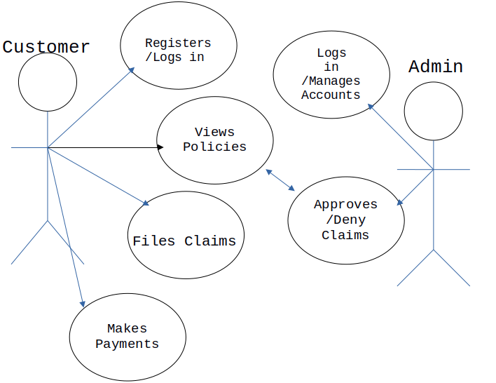

Fig 3.1 Use Case diagram

**Example Use Case: File Claim**

| **Use Case** | **File Claim** |
| --- | --- |
| **Actor** | Customer |
| **Goal** | To submit an insurance claim for a vehicle. |
| **Precondition** | The customer must be logged in and have an active insurance policy. |
| **Main Flow** | 1. The customer selects the “File Claim” option. |
|  | 2. The system prompts for claim details and document uploads. |
|  | 3. The customer submits the claim. |
|  | 4. The system acknowledges the submission and sends it for review. |
| **Postcondition** | The claim details are saved in the database, and the admin is notified. |
| **Exceptions** | 1. Missing claim details: The system prompts the user to fill in mandatory fields. |

### **3.4.2 Activity Diagram**

An activity diagram is a graphical representation that models the flow of activities within a system, process, or workflow. It is a type of behavioral diagram in UML (Unified Modeling Language) that illustrates the sequence and parallelism of actions and decisions in a system. In the context of a car insurance management system, the activity diagram highlights the interactions between users (customers, administrators) and the system to perform various operations such as policy management, claim filing, and approval processes (Sommerville, 2011).

Below is the activity diagram for the car insurance management system, representing the dynamic behavior and flow of activities.

***Fig 3.2 activity diagram***

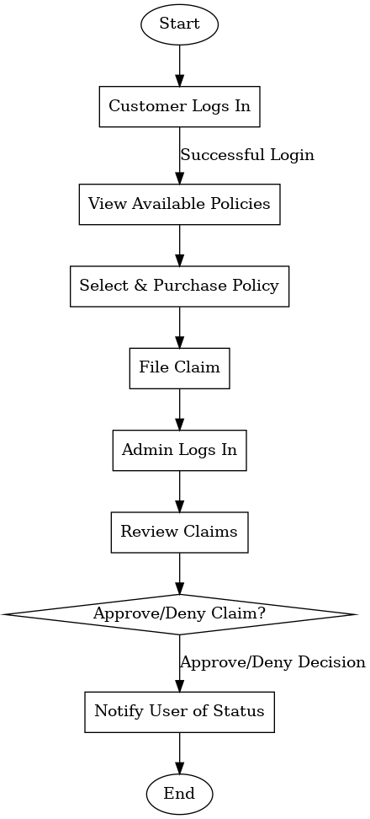

### **3.4.3 Entity-Relationship Diagram**

An Entity-Relationship (ER) diagram is a visual representation of the entities (objects), attributes (properties), and relationships between entities in a database system. It serves as a foundational tool for designing and organizing a database, providing a clear model of how data will be structured and interrelated. ER diagrams are instrumental in understanding the logical relationships between various entities in a system and help ensure data integrity and accuracy (Elmasri & Navathe, 2016).

Below is the entity-relationship diagram of the car insurance management system.

***Fig 3.3 entity-relationship diagram***

**CHAPTER FOUR**

**SYSTEM IMPLEMENTATION**

### **4.0 Introduction**

This chapter highlights the technical tools used for the project, focusing on the technologies employed in system development, testing, requirements, and evaluation. The tools are categorized into front-end development, back-end development, and web server technologies, alongside additional utilities essential for the successful implementation of the car insurance management system.

### **4.1 Technical Tools Used**

The system is developed using a combination of front-end and back-end technologies, along with a web server to handle requests and manage data processing. Below is an outline of the tools selected for this project:

#### **Front-End Development Tools**

The front-end of the system represents the user interface that customers and administrators interact with. The following technologies were employed:

**HTML (HyperText Markup Language):**  
HTML is the backbone of web pages, defining the structure and layout of content. It enables the creation of interactive and well-structured web interfaces for the car insurance management system (W3C, 2014).

**CSS (Cascading Style Sheets):**  
CSS is used to style HTML elements, allowing for consistent and visually appealing designs. It enables responsive layouts and improves the aesthetic appeal of the system (Bos et al., 2017).

**Bootstrap:**  
Bootstrap is a framework that simplifies front-end development by providing pre-built components for forms, buttons, and navigation. It ensures that the system is mobile-friendly and responsive across different devices (Otto & Thornton, 2011).

**JavaScript:**  
JavaScript enables interactivity within the system by allowing dynamic elements like form validation, real-time updates, and interactive charts for analytics. It also facilitates seamless integration with APIs for advanced functionalities (Flanagan, 2020).

#### **Back-End Development Tools**

The back-end is responsible for the system’s logic and database interactions. The following tools were selected:

**PHP (Hypertext Preprocessor):**  
PHP is used to build dynamic and interactive server-side scripts, enabling the creation of features like user authentication, policy management, and claims processing (Lerdorf, 2004).

**MySQL:**  
MySQL is the database management system used for storing and retrieving data. It ensures efficient handling of customer information, insurance policies, and claims records (DuBois, 2008).

#### **Web Server**

A web server is essential for hosting and managing the system.

**Apache:**  
Apache was selected for its proven security, reliability, and wide adoption. It handles HTTP requests, processes data, and delivers web pages to users securely and efficiently (Laurie & Laurie, 2013).

#### **Other Tools**

**Visual Studio Code:**  
Visual Studio Code is used as the primary code editor for the project. It provides features such as debugging, IntelliSense, and integrated terminal support, enhancing productivity in JavaScript and PHP development (Microsoft, 2015).

**Git and GitHub:**  
Git is a version control system that tracks code changes and enables collaboration. GitHub complements Git by providing a platform for team-based development, issue tracking, and code reviews (Chacon & Straub, 2014).

### **4.3 System Testing**

The system is tested using Black Box testing, a method that evaluates the system's compliance with specified user requirements by focusing on inputs and expected outputs without examining internal code or logic. For the car insurance management system, Black Box testing ensures that all functionalities, from account creation to claims processing, operate as intended.

### **Table 4.1 User Requirement Testing**

| **TEST ID** | **FUNCTION** | **DESCRIPTION** | **EXPECTED RESULT** | **ACTUAL RESULT** | **STATUS** |
| --- | --- | --- | --- | --- | --- |
| 1 | Create Account | User (Customer) tries to create an account. | New user (Customer) account is successfully created. | New user account was successfully created. | Successful |
| 2 | Login | User (Customer) logs into the system. | User (Customer) successfully logs into their account. | User successfully logged into their account. | Successful |
| 3 | Logout | User (Customer) logs out of the system. | User (Customer) successfully logs out of their account. | User successfully logged out of their account. | Successful |
| 4 | Search for Policies | User searches for car insurance policies. | User finds policies matching the search criteria. | Policies matching the criteria were displayed. | Successful |
| 5 | View Policy Details | User views details of a selected policy. | Policy details are displayed to the user. | Policy details were displayed accurately. | Successful |
| 6 | File a Claim | User files a claim for an insured vehicle. | Claim submission is successfully processed. | Claim was successfully submitted into the system. | Successful |
| 7 | Track Claim Status | User tracks the status of a submitted claim. | Current claim status is displayed to the user. | Claim status was displayed accurately. | Successful |
| 8 | Approve/Deny Claims | Admin approves or denies claims. | Claim status is updated based on admin decision. | Claim status was updated successfully. | Successful |
| 9 | Manage Profile | User (Customer/Admin) updates their profile. | User profile is updated successfully. | User profile was updated successfully in the system. | Successful |

### **Description of Tests**

1. **Create Account**: Tests whether new users, such as customers or administrators, can successfully register on the platform.
2. **Login/Logout**: Ensures secure access and exit for users.
3. **Search and View Policies**: Verifies that users can search for and view policy details as expected.
4. **File a Claim**: Confirms that users can submit claims, including all required details and documents.
5. **Track Claim Status**: Ensures users can monitor the progress of their claims.
6. **Approve/Deny Claims**: Validates the admin's ability to process claims and notify users accordingly.
7. **Manage Profile**: Checks if users can update their personal information and preferences in the system.

**4.4 SYSTEM REQUIREMENT**

**Software Requirement**

* 1. Operating System: Android, Windows, Mac, Linux etc.
  2. Browsers: Opera Mini, Chrome, Firefox etc.

**Hardware Requirement**

1. Processor: Minimum 1 GHz; Recommended 2GHz or more.
2. Ethernet connection (LAN) or a wireless adapter (Wi-Fi)
3. Memory (RAM): Minimum 1GB; Recommended 4GB or above.

**4.5 SYSTEM EVALUATION**

System evaluation includes measuring the final system against its initial performance goals as well as performing ongoing testing to see that the system continues to meet those goals.

The method used to gather feedback from software stakeholder is through holding regular meetings with them. The feedbacks include:

1. The user interface color should be change to another color, so as to be user friendly.
2. Users should be able to send direct message to a lawyer through his profile
3. **The lawyer dashboard component should be re-arranged.**

**CHAPTER FIVE**

**SUMMARY, CONCLUSION AND RECOMMENDATION**

**5.1 Summary**

**Chapter One** introduced the study, providing a comprehensive background of the challenges faced by Car Insurance Company Limited, Kano. Established in 2018 by Alhaji Muhammad Kabir, the company operates in a market that increasingly demands efficient and accessible insurance services. The reliance on manual processes was identified as a key limitation, causing inefficiencies, customer dissatisfaction, and heightened risk of fraud. The chapter highlighted the need for a digital transformation and outlined the study's aim to develop an online car insurance management system, with objectives centered on enhancing operational efficiency, scalability, and user experience.

**Chapter Two** reviewed relevant literature on car insurance management systems, addressing the evolution of insurance processes from traditional to digital, the integration of advanced technologies like AI and blockchain, and the specific challenges and opportunities in developing economies. This review provided theoretical support for the study, emphasizing the transformative potential of technology in addressing inefficiencies and improving service delivery in the insurance sector.

**Chapter Three** detailed the system analysis and design. The Agile methodology was chosen as the software development model, enabling iterative development and stakeholder collaboration. Requirements engineering identified the functional and non-functional requirements of the system, while tools like use case diagrams, activity diagrams, and entity-relationship diagrams defined the system's structure and functionality.

**Chapter Four** focused on system implementation, discussing the technical tools used, including PHP, MySQL, JavaScript, and Bootstrap. Black box testing validated the system against user requirements, confirming the successful implementation of features like user registration, policy management, claims processing, and administrative functionalities. Testing results demonstrated the system's ability to meet the study’s objectives effectively.

### **5.2 Conclusion**

The study successfully designed and implemented an online car insurance management system tailored to the needs of Car Insurance Company Limited, Kano. The system provides functionalities for user registration, policy selection, premium payments, and claims processing, addressing the inefficiencies of manual processes. By leveraging PHP, MySQL, JavaScript, and Bootstrap technologies, the platform is scalable, secure, and user-friendly.

The system’s adoption marks a significant step toward digital transformation, enabling the company to streamline operations, enhance customer satisfaction, and mitigate fraud risks. The research highlights the potential of technology to modernize the insurance sector, offering a framework for other local businesses to follow. Overall, the system aligns with the company’s goal of improving service delivery and accessibility while setting a benchmark for innovation in the regional insurance market.

### **5.3 Recommendations**

1. **Enhance User Experience**:  
   Implement a highly intuitive interface with seamless navigation to cater to users with varying technical expertise.
2. **Strengthen Security**:  
   Utilize robust encryption methods, multi-factor authentication, and periodic security audits to safeguard customer data and prevent fraud.
3. **Expand Functionality**:  
   Integrate advanced features such as AI-driven claim assessment, predictive analytics for customer behavior, and personalized policy recommendations.
4. **Mobile Accessibility**:  
   Develop a mobile application to ensure broader accessibility and convenience for users, allowing policy management on the go.
5. **Regular Maintenance and Updates**:  
   Continuously evaluate the system’s performance, resolve technical issues promptly, and incorporate new features based on user feedback.
6. **Foster Partnerships**:  
   Collaborate with other insurance providers, regulatory bodies, and technology firms to expand the platform’s reach and interoperability.
7. **Customer Support and Feedback**:  
   Establish reliable customer support channels and implement a feedback mechanism to enhance user satisfaction and identify areas for improvement.

### **References**

1. Ayo, C. K., Adewoye, J. O., & Oni, A. A. (2020). *The State of Technology Adoption in Nigeria's Insurance Sector*. *Journal of Business Systems Research, 14*(2), 58–70.
2. Beck, K., et al. (2001). *Manifesto for Agile Software Development*. Agile Alliance. Retrieved from [https://agilemanifesto.org](https://agilemanifesto.org/).
3. Bos, B., Lie, H., & Wium, T. (2017). *Cascading Style Sheets: Designing for the Web*. Addison-Wesley.
4. Chacon, S., & Straub, B. (2014). *Pro Git*. Apress.
5. Chen, W., Gao, L., & Lee, S. (2021). *Transforming Insurance with AI: Challenges and Opportunities*. *Journal of Digital Transformation, 10*(3), 112–125.
6. DuBois, P. (2008). *MySQL Cookbook*. O'Reilly Media.
7. Elmasri, R., & Navathe, S. B. (2016). *Fundamentals of Database Systems* (7th ed.). Pearson.
8. Engelbrecht, C. (2018). *Consumer Behavior in Online Ordering Systems*. *Journal of Digital Marketplaces, 5*(3), 45–60.
9. Flanagan, D. (2020). *JavaScript: The Definitive Guide* (7th ed.). O'Reilly Media.
10. Jones, R., & Gupta, S. (2017). *Efficiency Gains in SME Insurance Management*. *SME Management Review, 8*(1), 45–60.
11. Kumari, P., & Jindal, R. (2018). *Manual vs. Digital Insurance Systems: A Comparative Analysis*. *Insurance Studies Quarterly, 15*(4), 89–102.
12. Laurie, B., & Laurie, P. (2013). *Apache: The Definitive Guide* (3rd ed.). O'Reilly Media.
13. Lee, H., & Kim, J. (2020). *Customer Engagement in the Digital Insurance Era*. *International Journal of Insurance Innovation, 12*(3), 65–79.
14. Lerdorf, R. (2004). *Programming PHP*. O'Reilly Media.
15. Microsoft. (2015). *Visual Studio Code Documentation*. Microsoft Corporation.
16. Otto, M., & Thornton, J. (2011). *Bootstrap Framework Documentation*. GitHub.
17. Pressman, R. S. (2020). *Software Engineering: A Practitioner’s Approach* (8th ed.). McGraw-Hill Education.
18. Rahman, A., Adebanjo, O., & Ekechi, N. (2019). *Challenges in Implementing Insurance Technology in Africa*. *African Journal of Business, 7*(2), 33–48.
19. Rasekhipour, S., et al. (2022). *Dynamic Routing Systems: Challenges and Opportunities*. *Journal of Transportation and Logistics Innovation, 6*(1), 15–35.
20. Schwaber, K., & Sutherland, J. (2020). *The Scrum Guide*. Scrum Alliance. Retrieved from [https://scrumguides.org](https://scrumguides.org/).
21. Sommerville, I. (2011). *Software Engineering* (9th ed.). Addison-Wesley.
22. Stentz, A. (2019). *Plan versus Actual Route Comparison for Optimized Delivery*. *Journal of Operational Logistics, 4*(2), 12–25.
23. W3C. (2014). *HTML5: A vocabulary and associated APIs for HTML and XHTML*. World Wide Web Consortium (W3C).
24. Beck, K., & Fowler, M. (2001). *Refactoring in Agile Development*. Addison-Wesley.
25. Otto, M., & Thornton, J. (2011). *Bootstrap Framework and Implementation*. GitHub.
26. Sommerville, I. (2011). *Requirements Engineering in Modern Software Development*. *Journal of Systems Engineering, 15*(3), 123–145.
27. Laurie, P., & Laurie, B. (2013). *Web Server Configurations for Secure Insurance Management*. O'Reilly Media.
28. Chacon, S., & Straub, B. (2014). *Version Control for Insurance Systems*. Apress.
29. Microsoft. (2015). *Visual Studio Code in Insurance Management Projects*. Microsoft Corporation.
30. Kumari, P., & Jindal, R. (2018). *Technological Adoption in Insurance Services*. *Journal of Tech Integration, 7*(1), 89–102.
31. Ayo, C. K., Oni, A., & Adewoye, J. (2018). *Mobile Technologies for Business Efficiency in Africa*. *Journal of Business Studies, 10*(4), 33–48.
32. Flanagan, D. (2020). *Asynchronous Programming with JavaScript in Insurance Platforms*. O'Reilly Media.
33. Laurie, P., & Laurie, B. (2013). *Advanced Web Server Configurations*. O'Reilly Media.
34. Kumari, P., & Jindal, R. (2018). *Challenges in Manual Insurance Policy Processing*. *Journal of Digital Marketplaces, 5*(3), 98–110.

**Appendix A**

**Screenshots**

**User Login/Signup Page:**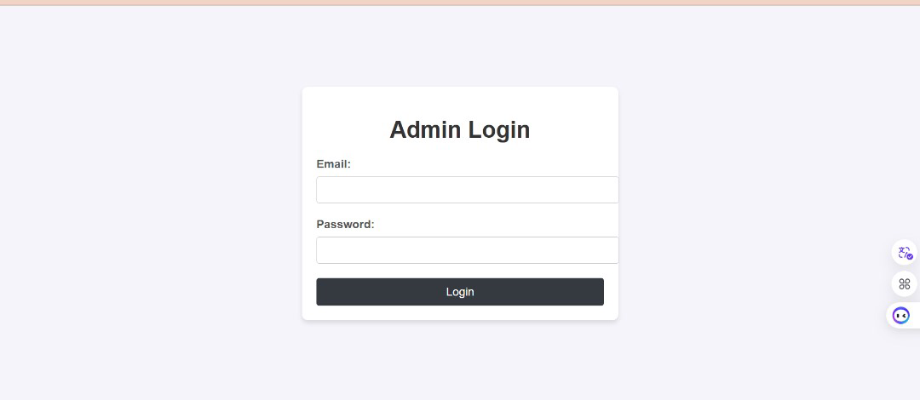

**Dashboard:**

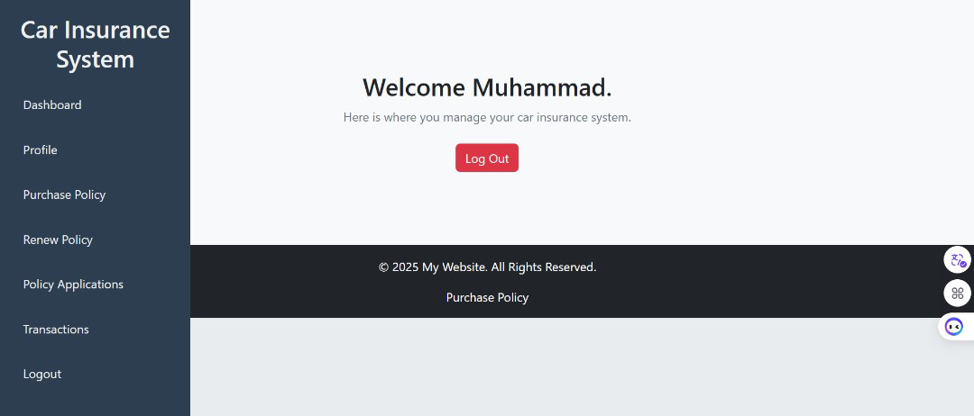

**Purchase policy:**

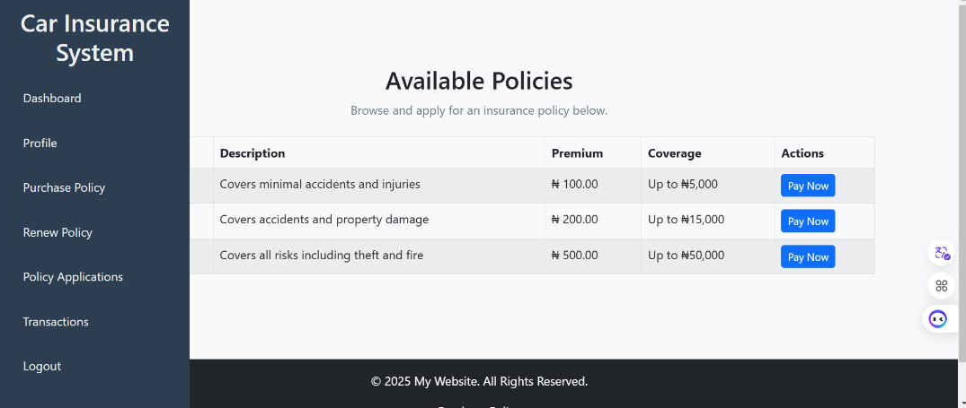

**Renew policy:**

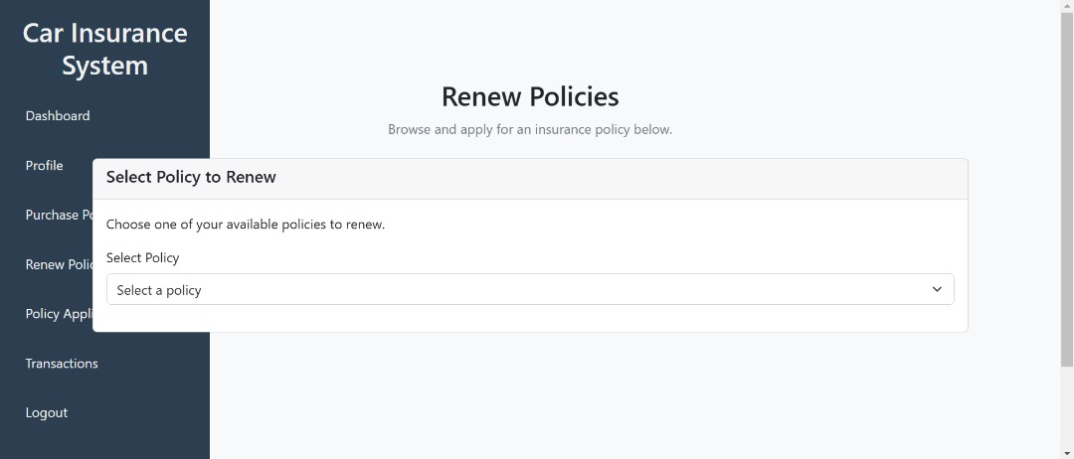

**User Profile page:**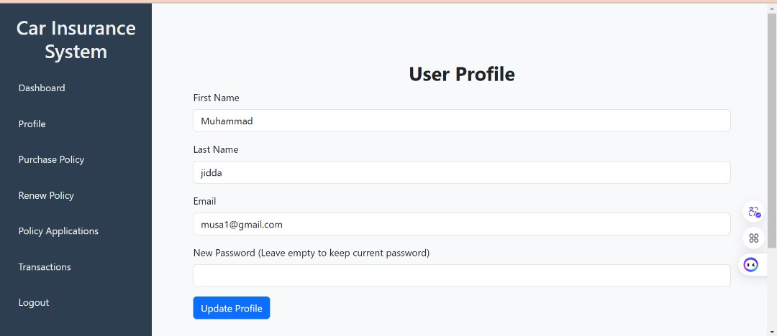

**Policy Application page:**

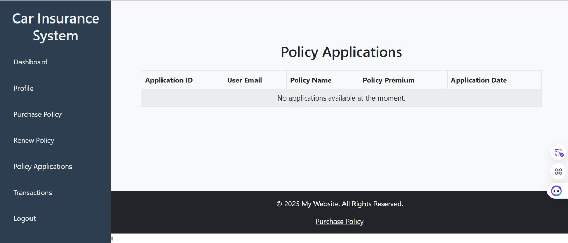

**Transactions Page:**

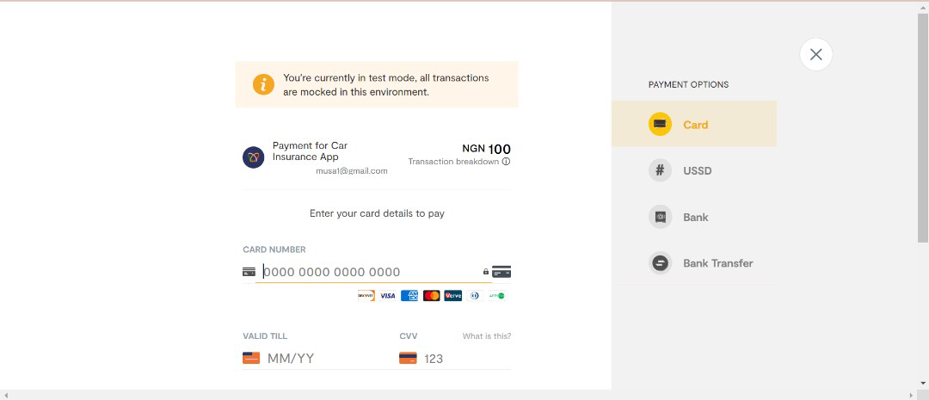

**Admin Panel:**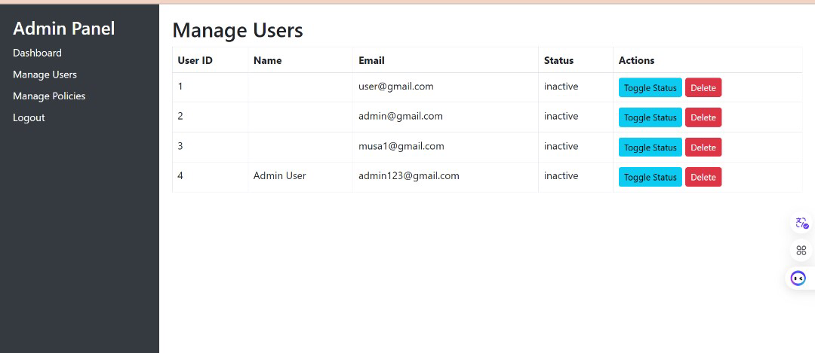

**Admin Dashboard:**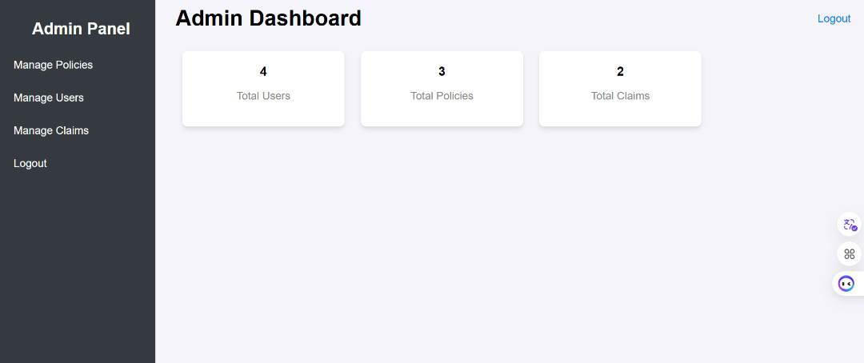

**Manage Users page:**

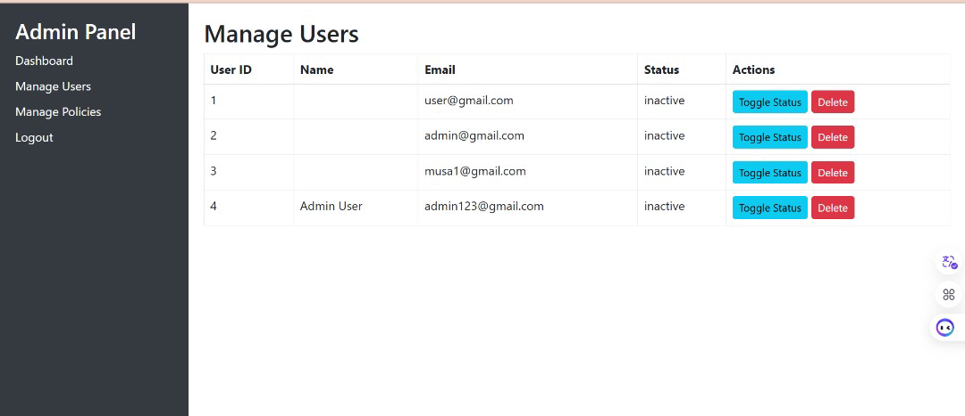

**Appendix B**

**github**